Trading Visualization Assignment design document

Project:
Visual C# stock/trading visualization assignment no. 1

Summary
Visual Studio C# WPF project that utilizes a SciChart visualization component in order to displays stock market data and specific technical indicators. It uses external data sources - .csv files.

Architecture Design
The application consists of one WPF window in which is embedded an instance of SciChart FastCandlestickRenderableSeries chart and an instance of SciChart FastLineRenderableSeries chart. Candlestick chart utilizes OHLC Data Series.
It also includes one combo box control that allows the user to choose between existing stocks and a checkbox which defines volume representation mode.

Graphical User Interface

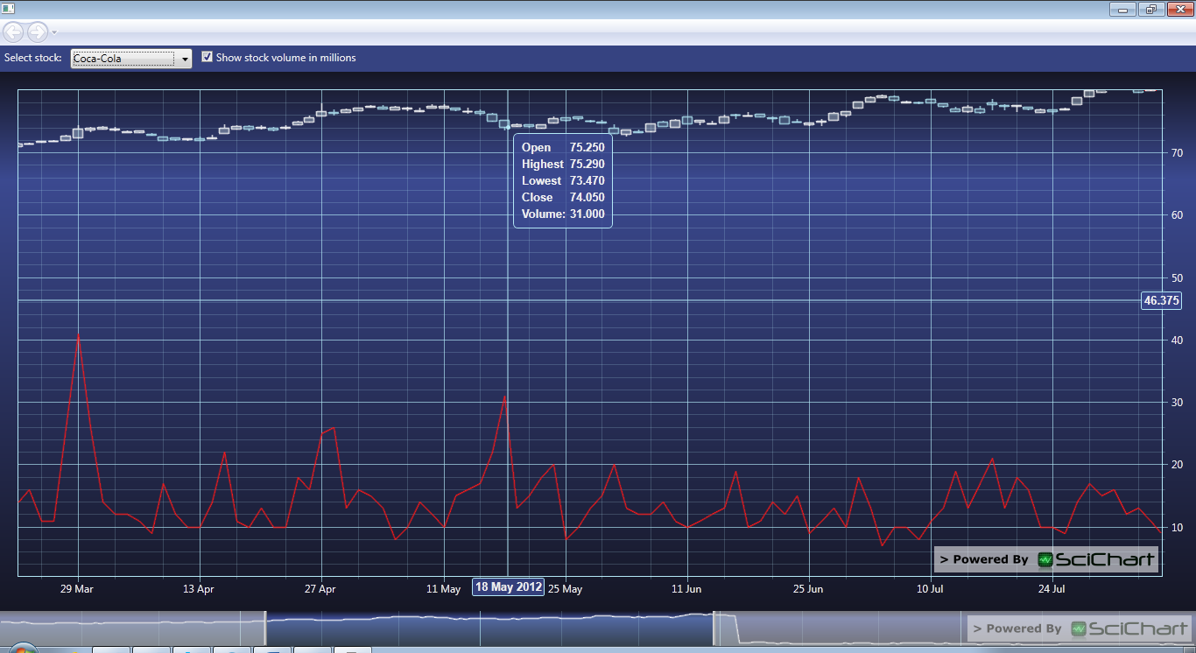

Data sources
Data used for this project are publicly available sources of stock’s trading.
Several companies were chosen and their stock changes in the year 2012.
The format in which the data is provided are .csv files with the structure:
Date <date> – trading day
Open <double> – stock price on the opening
High <double> – the highest stock price for that day
Low <double> – the lowest stock price for that day
Close <double> – stock price on the closing
Volume <integer> – volume of stocks traded for that day

Class Diagram and Classes
- public MainWindow()
Initializes the application and asks the user to provide the location of data source files and then loads the list of the available stock files into the combo box control
- private void cboStockChanged(object sender, SelectionChangedEventArgs e)
Triggered by the change of selected combo box item. Calls the function to load selected stock’s data
- private void cbChecked(object sender, RoutedEventArgs e)
Changes the mode of volume representation – absolute vs. in millions
- private DataSeriesSet<DateTime, double> ReadStockData(String sFileName)
Reads stock’s data, checks the structure of the file and data types and provides it as a source for the chart

References
SciChart provided documentation and examples for different usage of their tool.

